Appendix

Appendix A

January 2021

Dear Madawaska Adventures Staff,

We would like to welcome the Madawaska adventurers (that’s you) to your new line of everything happening here at Madawaska. As you may have already noticed, there have been a lot of changes happening within our family. Change can be scary, but more importantly, change can be exciting! During this year and more to come, Madawaska Adventures will be initiating a lot of change to help the upper-level management better understand and appreciate the people who keep our doors open daily—both customers and employees like yourself.

Beginning very soon, we will be introducing new software that will make receiving and viewing your schedule so much easier, as well as more fun. The app has a platform that resembles some popular social media tendencies. We would love to see our employees utilize this app not only to schedule but document the fun adventures you experience in and outside the front doors of Madawaska. Going on a hike? Tell us what you saw! Driving down the countryside? Share the breath-taking view, so that we can all enjoy it. Forgot to book a weekend off to go see your grandma? Post your shift so your coworkers can easily cover for you. This app is going to revolutionize how we do things around Madawaska.

Facing change can be daunting, and Madawaska Adventures wants to assure everyone that the difficult part is now over and that we are looking to the future. If you have any questions or concerns about the changes that are coming, we strongly recommend you reach out to your manager as soon as possible so that we can put your concerns to rest.

Venture on,

Matts & Sofie Andersen

Appendix B
January 2021
Dear Michael,

We know this year has been an incredibly challenging time for all of our staff. In most cases, we’ve had to put a pause on the things we love doing—adventuring included. With much of the uncertainty that we found ourselves in this year came a great deal of opportunity.

We’re writing to you today to talk about the changes that are coming to Madawaska. Change can be scary, but more importantly, change can be exciting. Over the course of this year, Madawaska Adventures will be initiating change that helps upper-level management better understand and appreciate the people who keep our doors open daily—both customers and employees like yourself.

Beginning shortly, we will be introducing new software that will make communication easier and much more fun. We want to see our employees use this app to document their adventures inside and outside Madawaska’s front doors. Schedules will be available online as well, which makes swapping shifts to fit your life that much easier. This app is going to revolutionize how we do things around Madawaska.

We want to make sure your voice is being heard while we go through these changes. We want to know your honest opinions on what is and is not working. You’ll be given several opportunities to tell us your thoughts, and we encourage you to tell us them!

We have set up a dedicated email address for all employees who may have questions regarding the coming changes. If at any point you have a question, please email askmadawaska@outlook.com. Your inquiry will be answered within 48 hours by a member of Human Resources.

At the end of this month, we will be holding a virtual Town Hall, which we invite all employees to attend. This will give us a chance to talk about the changes coming to Madawaska and address any concerns you may have.

Facing change can be daunting, but Madawaska Adventures wants to assure everyone that the difficult part is over. We’re looking to the future, and it’s looking bright. If you have any questions or concerns before the Town Hall meeting, we encourage you to reach out to your manager as soon as possible so that we can put your concerns to rest.

Venture on,
Matts & Sofie Andersen

Appendix C

(Send out first week of January)
Good Morning/Afternoon Madawaska management,

Firstly, we want to wish everyone a very Happy New Year. 2020 has brought everyone nothing but surprises and hardships. However, we made it through and are preparing to look forward to bigger and better things. And what better way to do so than within Madawaska itself.
As we are all aware, Madawaska has pulled through and survived a tough year in sales, especially in lieu with COVID-19 and the uncertainty it brought to our retail stores. We had a rough go in 2020, but near the last quarter, with the high volume of online-purchases, we managed to break even this year (which we are very happy about).
With this being said, Madawaska is undergoing a major change this year, which will set the groundwork for becoming the norm. There is no need to be alarmed or worried about these changes, as they will be seamless, easy, and will not disrupt any business operations. These changes will improve the company long term and allow the company to grow without changing Madawaska’s dedication to having a work hard, play hard environment.
The changes being made focus on building a better, stronger and more stable communication system within all Madawaska outlets. That means better communication between corporate staff and managers at retail and outdoor facilities, better employee and manager relations within retail stores, and better involvement and team-building between all outlets (Madawaska Outdoor Facilities, retail stores and corporate offices).
These changes start with us here at corporate, reaching out to retail and outdoor facilities managers. There will be a rollout of a new online platform software that we will use to be in communication in the upcoming weeks. For now, an email will have to do. There will be more information about this online platform coming, but for now, Madawaska employees will need to be informed about the upcoming changes. This email includes a list of talking points to use when holding shift meetings with employees about the changes coming.
If anyone has any questions, comments or concerns, please reach out to us through email. We will all work together on this. Also, there is a company-wide email that employees will be encouraged to write to and send in their questions, comments and concerns. In the future, these questions will be used to create a FAQ document that will be posted and updated regularly through the change.

Talking points for retail/outdoor facility managers:
· Individual emails will be sent out this month, acknowledging the changes being implemented at Madawaska. We advise you to make sure staff has read them.
· Briefly mention the online platform – but do not overload the staff with this information. As managers, you will be using the online platform first (coming in the upcoming months). Advise staff that an online software for communication and scheduling is on the way.
· Re-assure them the change is good; it will bring them closer, help with communication between all staff members, give them a sense of unity, and connection to leadership, help with team building, and create a sense of culture within Madawaska.

Company-wide email: askmadawaska@outlook.com

We look forward to the new way of adventures and teamwork here at Madawaska.

Best,

All of us at Head Office.

Appendix D

Town Hall Meeting Itinerary (script)
10 a.m. – Signing into Zoom & waiting for all to arrive
10:15 a.m. – Introduction & Welcome from HR
10:30 a.m. – Discusses the changes coming that were mentioned in the emails
10:45 a.m. – Open the floor for questions & answers
11:15 a.m. – Conclude

Script:
We hope everyone is staying safe and doing well during this time. As we are all aware, Madawaska is undergoing some changes moving forward. Though these changes seem large and out of the blue, we promise that this will not affect day-to-day operations, nor will it affect your work schedules or performances at work. Madawaska is simply moving forward, upgrading and evolving. And we are doing so while still having our employees’ best interest at the forefront.
We thank all of our front-line staff who are working hard in the retail stores during these times. We also want to thank our corporate and office staff who have adapted swiftly to working from home with no hiccups. We understand that these internal changes within Madawaska are happening while the outside world is changing, which can be an additional challenge! That’s why we have asked you here today. To break down the information you have received these last few weeks, to get your feedback, and hopefully answer any unresolved questions.

Talking Points:
· Re-read BOTH the company letter and the individual emails that were sent out (to make sure all attendees have read it, and if they didn’t, they could hear it for the first time now)
· Briefly mention the Workplace app – but do not overload the staff with this information. This will come in a couple of months. Make sure they are aware it is coming but do not alarm them.
· Re-assure them the change is good; it will bring them closer, help with communication between all staff and managers and give them a sense of unity.

*Open the floor to the Q&A as well as receiving feedback. As well, mention the company-wide email that will be used for further questions. (This information/feedback from employees will then go into the FAQ document and also be used to influence the surveys).*

Company wide email: askmadawaska@outlook.com

Conclude:
Again, thank you everyone for taking time out of your day to be here and hear about what is coming to Madawaska. We want to emphasize again that these changes will not disrupt the flow of business, and employees are being looked at as the first priority in this transition. Together, as a Madawaska team, we will move forward with a better and brighter workplace and feel more connected with one another than before.
Have a great day.

Appendix E
Hello adventurers,
We are excited to introduce the new communication platform that we will be implementing here at Madawaska Adventures. The company has decided to move forward on utilizing the Workplace platform as our new means of communication. Staying connected here at Madawaska Adventures is about to get 10 times easier.
We ask that all managers take the time over the next few weeks to create a Workplace profile and become more familiar with the software. We have chosen Workplace because it is easy to use and user friendly. We expect the app to improve day-to-day communications between managers and staff as it will become the main contact channel. Having all Madawaska Adventures employees on the same platform will also enable ease of communication between different branches and store locations. For now, we are introducing it to you, the management team so you are better equipped with the function, that way you can relay the information to retail/outdoor employees when the time come
In the past, we have used email as the primary source of communication when delivering messages such as newsletters, company announcements, surveys and FAQ’s. During this transition period, we will start to use the Workplace app to disseminate these types of documents and send them by email until everyone is confident in using the new platform.
We have attached a video file that introduces the platform and how up a personal profile to help you get started. Please take the time to review the video and begin the workplace adventure.
We hope that this platform will become a place where all Madawaska Adventures employees can share their stories and experiences, in-store and in nature. We encourage you to reach out and connect with one another to build friendships and connections because here at Madawaska, we are a family.
Adventure is always on the horizon,
Sofie Andersen, COO



Appendix F
Workplace How-To Videos:
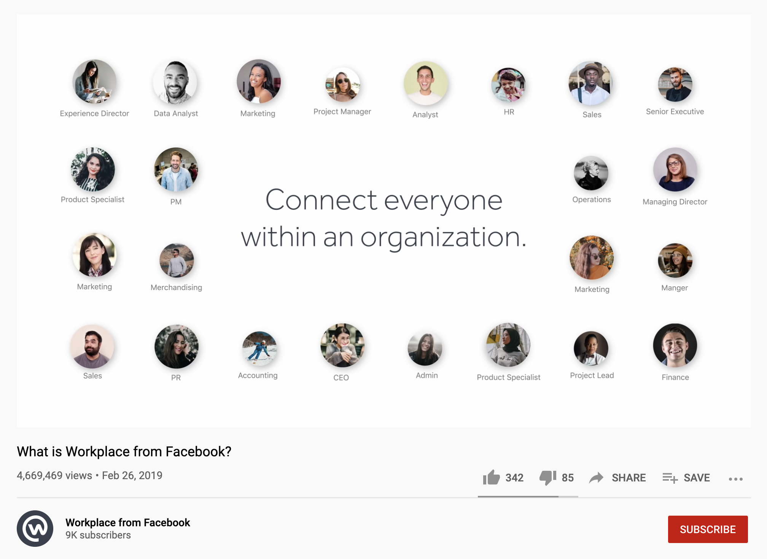

https://www.youtube.com/watch?v=aLUBY2q7TLw
This video, which outlines how to navigate Workplace, will be sent to management (and then later to employees in phase two) via the introduction email sent by Sofie. It briefly details what the app is for and how it can help the company.

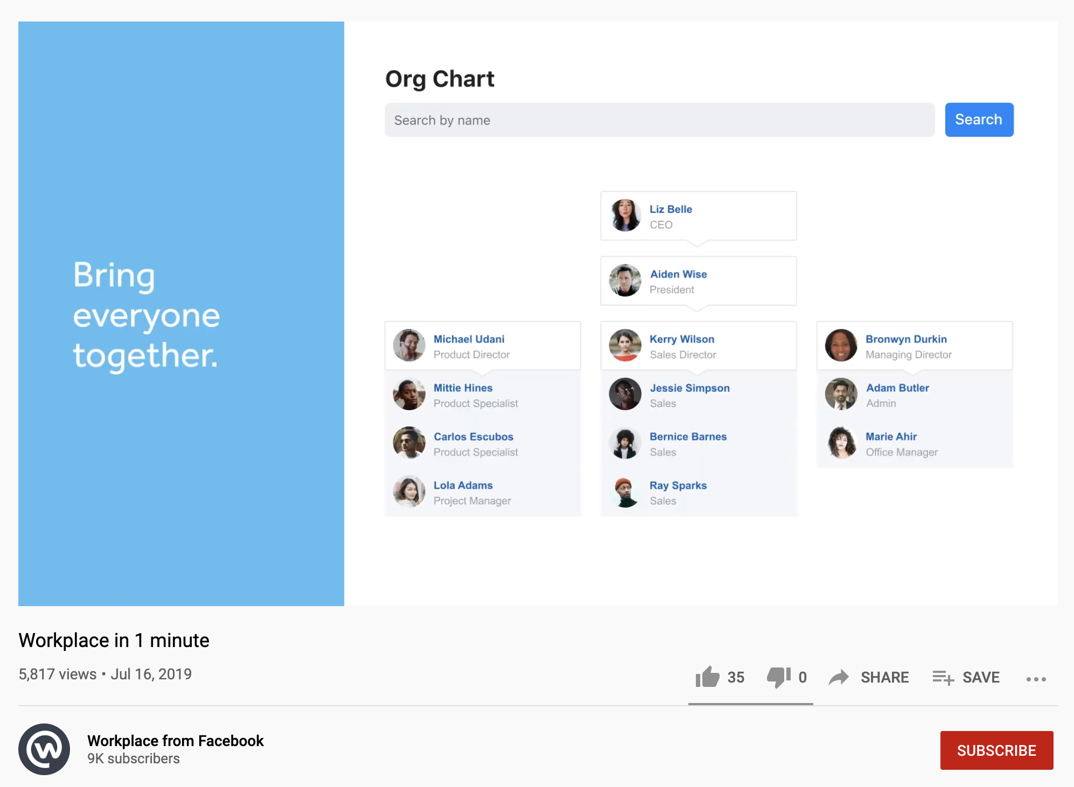

https://www.youtube.com/watch?v=Cnb2FUaMQZY
This video will also be sent in the same email. It details the functions of the app and its different features.

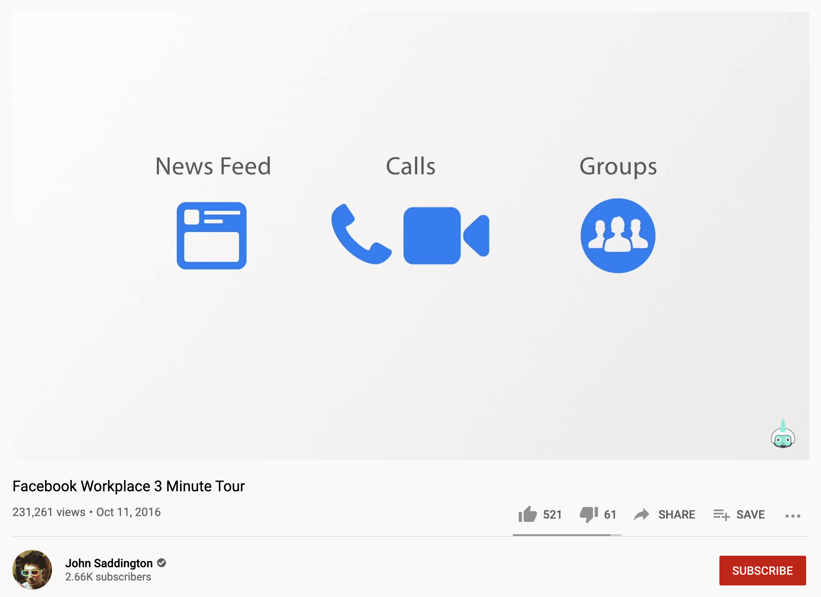

https://www.youtube.com/watch?v=YSJHyfOUXhQ
Lastly, this video will be sent to show each feature in more detail.

Appendix G

Madawaska Adventures is no stranger when it comes to tackling adventure. Nothing is too big for our team members whether it be zip-lining through the trees or water-skiing down an open lake. This mindset has been instilled in the Andersen family ever since Tor Andersen founded Madawaska Adventures in 1971. And Tor’s kids have been keeping the adventure alive ever since.
Sofie Andersen, Madawaska Adventures Chief Operating Officer (COO), is a hard-working, dedicated and passionate team member. She is always eager to step in and help when needed and isn’t afraid to make tough calls that help move Madawaska’s business forward. Having extensive experience in adventure and business, she uses her skills to move Madawaska Adventures forward for it to be the best profiting company her father set it out to be.
Having been in the retail sector her whole life, Sofie has tremendous social skills and applies them to everything she does. If you need someone to call a distributor to make sure the order is coming on time, she’s there to do so. If you find yourself having a particularly hard day at work, she’s there to come by and lighten the load. Her charm and charisma are contagious, making the office a cheery place for all to enjoy.
Madawaska plans to extend this cheery atmosphere to all of our outlets. That way all employees get to experience the true nature of who Sofie is.
Sofie graduated from the University of Ottawa with a Bachelor in E-Commerce and a Master of Science in Management from Queens University. Throughout her schooling, she spent her summers at Madawaska Adventures White Water School, helping her father and brother run activities and programs there and interned at the Toronto head-office during her final year at Queens.
We are lucky to have such a skillful leader on the team here at Madawaska, and we couldn’t be happier to have her be in the lead of our sales. With her at the forefront, Madawaska Adventures can only grow and prosper.
Make sure to introduce yourself to Sofie either through email, Zoom calls or in person at the office when the opportunity arises.

Appendix H
- I have heard about the changes coming to Madawaska and have a good understanding of them:

(strongly disagree) (disagree) (neutral) (agree) (strongly agree)

- I am inspired by the direction and mission that Madawaska is working towards:

(strongly disagree) (disagree) (neutral) (agree) (strongly agree)

- I feel as though my voice will be heard when it comes to giving feedback and making changes:

(strongly disagree) (disagree) (neutral) (agree) (strongly agree)

- Do you have any concerns about the changes that will be happening to Madawaska?:
(open-ended answer)
(yes) (no)
If answered yes, comment here:

- Would there be something you want to see change in our company culture going forward?:
(open-ended answer)
(yes) (no)
If answered yes, comment here:

Appendix I

*This document will be updated regularly as new questions/comments/concern arise*

Will there be any layoffs/closures?
Currently, we have not received any information about layoffs or closures. Please contact your retail store manager as they will let staff know about any layoffs or closures. Madawaska does not want to lose any member of its staff, and we’re doing everything to make sure that does not happen.

(*if there are changes, a different draft will be made & more communication tactics would be used to correlate with the closures. This would just be one of many*:)

Due to the unprecedented times Madawaska is facing, some outdoor facilities and retail stores are seeing their last days. The team at Madawaska’s head office did everything they could to try and avoid this scenario and we are very upset to see some of our doors close for good. Your managers will be in contact with you about the protocol that is in place to close if your store/outdoor facility is part of the ones. We thank you all for your committed engagement and hard work here at Madawaska and hope to see you again at another Madawaska outlet in the future.

How will this change my day-to-day hours/shifts?
Retail store operations will continue to run during their dedicated store times. There will be no disruption to the flow of work. Schedules will still be posted every week at the same time on Monday’s. Part-time and full-time staff’s hours will not be affected either. These changes will only enhance the workflow, help better keep staff organized, and make scheduling easier. There will be no disruption and the transition will be smooth and easy.

How long will these changes be in place?
Indefinitely. We will work together as the changes come to us, ensuring the transition to digital scheduling and software compatibility is smooth and seamless. Again, there will be no hiccups in day-to-day operations and our dedication to having a work hard, play hard environment will not change.

Will there be a new management team?
Store management is not going to change. Other changes may happen, but nothing is currently planned. That said, if there are changes, we are committed to informing our people as soon as we can, including the reasons, rationale and employee impact of any changes.

Is there going to be more frequent meetings with staff to keep us updated on what’s happening?
Yes, Madawaska is working on making sure staff and employees are being updated on the changes regularly. There will be shift meetings happening regularly, emails and bulletin board posts going up detailing what is going on, and management and head office communications will constantly be flowing. Again, if there are any more questions, comments, or concerns, please do not hesitate to reach out to us.

Are other stores being affected by these changes as well?
Yes, these changes are Madawaska wide. Retail stores, Madawaska outdoor facilities and corporate offices are all undergoing the same process. We are all in this together and will continue to support each other during these times.

Was your question not answered? Email it to askmadawaska@outlook.com and we will get back to you within 48 hours with an answer, update, or direct you better.

Appendix J
List of questions we are asking the focus group

During this time (in phase two), employees from all Madawaska locations would have been introduced to, trained in using, and have incorporated the use of the Workplace app. This focus group will take place within the summer months of July or August 2021 (if the plan continues on the projected trajectory). The reason for this is so the retail/outdoor facility employees would have had enough time (3 to 4 months) to properly come up with any comments/concerns to send to their management team. In addition, managers and corporate staff would have been using the app for double that time, and their input on the questions will be more advanced. However, all feedback is necessary and is why this focus group is being conducted with employees of all levels.

1. How has using the Workplace app changed work-day flow?
2. Is everyone using the Workplace app?
3. Are there any struggles or issues with the software that employees or managers are experiencing?
4. What is the most common issue that the Workplace app has given staff (if any)?
5. Was figuring out how to use Workplace easy or hard?
6. Are there any suggestions you have to help improve the use of the software?
7. Is there anything you dislike about Workplace? If so, what would be a change you’d like to be made in order to fix the issue you are having with it?
8. Does the Workplace app make communication easier/more accessible between staff members/ managers relations?
9. Has using the Workplace app made it easier to stay connected with other staff members?
10. Are people using the built-in messaging system on Workplace?
We open the floor to anyone who has any additional comments/concerns/feedback they would like to discuss that was not mentioned in the questions we provided.
*The results of this focus group will go towards updating the FAQ document, influence survey questions, and help us determine if our objectives for this phase have been met*

Appendix K

Adventurer, go-getter, and hard-working are all the ways one can describe Matts Andersen, the son of our founder Tor Andersen. Madawaska Adventures has always had an explorer-focused leader, and that trait has been passed down to Matts.
As Chief Executive Officer (CEO) of Madawaska, Matts goal is to have the same attitude, mindset, and work-place culture his father had left behind. Filling in those shoes is no easy task, but Matts does an exceptional job doing so.
Living, breathing and working all things Madawaska Adventures is what Matts is all about. Ever since he was a little boy, he and his sister – Sofie – grew up working, playing and exploring the Madawaska Adventures lifestyle their father worked hard to build. Whether that was spending many summers at the White Water School, making weekend trips at the Madawaska Adventures Zip Lines park, even working in the retail stores during the school year to make some money. It was a no brainer to the Andersen family that Matts and Sofie would become the organization's new leaders.
Though Matts graduated from McMaster University with a Business Degree, his career has focused more on hands-on work. Having Tor as his mentor, Matts learned all the ins and outs of Madawaska, both in head office and on the floor within the retail spaces and the Madawaska Adventures outdoor facilities.
Matts considers the staff at Madawaska Adventures like an extension to his family, treating them as if they were his brothers and sisters. Following in his father’s footsteps, he has taken the same approach in his work. As CEO, Matts is eager and excited to meet all the staff that works for Madawaska Adventures and learn about every one of them.
A few of Matts’ favourite activities are rock climbing, water and snow skiing, hiking, and snowboarding. With working for Madawaska Adventures his whole life, he has embarked on many different experiences in the world of adventure. With it comes many different stories and tales about his endeavours. Matts is excited to share these stories with Madawaska Adventures employees and to also hear about their own experiences.
Make sure to check when Matts will be at your store and not miss out on meeting him. Madawaska Adventures is all about building lifelong friendships and connections, so connect with Matts and build the friendship of a lifetime.

Appendix L
Video: Matts’ introduction video
Casting: Matts Andersen
Job title: CEO
Organization: Madawaska Adventure
Publishing date: June 2021
Overview: Matts talks about what his outdoor hobbies are and tells us about the values his father instilled in him.
Length: 1:15

Content | Visuals | Audio
Intro/Fade in
---- | Black screen | Feet running on pavement
----- | Someone running towards the screen, you can only see their legs at this point | Feet running on pavement
My father, Tor, started Madawaska Adventures because he loved the outdoors. | Camera pans up, and you see the face behind the runner. It is Matts | Matts’ voice over
Have you ever heard of friluftsliv? It’s a Norwegian concept that roughly translates to “open-air” living. It’s about spending as much time as you can outdoors, no matter what the weather is like. | A shot of Matts rock climbing during the winter. The viewer sees his back, and he is moving up the frame. | Matts’ voice over  Outdoor noises
My sister Sofie and I grew up outdoors. We were always running, climbing or paddling. My father was committed to life outdoors, his and ours. | Close up of Matts rock climbing. Extra close shot of his hand on the rocks. | Matts’ voice over  Outdoor noises
He instilled the same sense of adventure that he had in his life into our lives. | Shot of Matts’ white-water rafting, starts in the top right of the frame, moves to the bottom left. | Matts’ voice over  Rushing water
As the years have passed, we’ve grown, both as business people and as adventurers. We want to see new things, try new activities and live bolder than ever before. | Shot of retail locations and the outdoor facilities. People working and smiling. | Matts’ voice over
That’s why I’m excited to see what the future has in store for us. | Shot of retail locations and the outdoor facilities. People working and smiling. | Matts’ voice over
I want to see us push the limits we’ve made for ourselves. I want us to overcome the challenges ahead of us, seek the opportunities in everything, be creative, stay true to who we are, and make lasting connections. | Shot of other outdoor activities | Matts’ voice over
There’s one thing that I know will never change. We’ll always live for the adventure. | Shot of outdoor activities. | Matts’ voice over
That’s why I’m proud to be a part of Madawaska Adventures. | We finally see Matts standing in front of a Madawaska store, smiling and saying this line. | Matts’ speaking

Appendix M

Hello Adventurers, Matts here! Welcome to your first introduction to our newsletter. I’ll be keeping everyone up to date with what I like to call “The Adventurer.” The Adventurer will be your one-stop location for everything Madawaska. Here, you will be able to find any information on new items we sell, updated safety practices and/or measures we will be endorsing at our outdoor facilities, and anything we consider bringing to our retail stores.

This letter will also be filled with any additional information about changes that are happening within the company. The Adventurer will be where you can see: Who was promoted to a new and exciting position, what products are most popular within staff (and customers), and anything exciting that I feel you would enjoy knowing.

Sometimes I’ll write about my personal experiences in the great outdoors (like that one time I got stuck in a tree branch from a canoeing trip gone wrong). Or, other times I’ll be sharing experiences from your fellow colleagues (this is where you can — and I encourage you do — submit fun and interesting stories to be shared).

Already thinking of a good one, send it to me at: theadventurer@madawaskainc.com

I look forward to embarking on this journey, and as the CEO of Madawaska Adventures, I hope you follow along and enjoy what you see here. I really do hope you feel inclined to share your personal experiences as well!

Venture on,

Matts Andersen

Appendix N

Matts’ Script for Workplace App:
(The Adventurer Newsletter Video Component)

Hey! What’s going on everyone? I’m Matts Andersen, CEO of Madawaska Adventures, and today we’re going to talk about the importance of getting a reusable water bottle.

A lot of people think that getting a reusable water bottle is all about saving the environment. And they’re not wrong. But it should be noted that a good water bottle can be essential to an everyday adventure. Personally, I like using my Nalgene bottle. These bottles come in all shapes and sizes as well. For a good happy medium, I would recommend the 36 oz. bottle. It’s going to fit inside your shoulder bag or backpack, which helps because it makes it easier to bring it on your adventure through the city, or on your next hike into the wilderness. These bottles are BPA free, and you can get them in all sorts of looks and colours! Just take a browse in our store and check it out for yourself.

Although these bottles will grab the attention of those around you and also keep you hydrated throughout the day, they do help cut down on the amount of plastic water bottle waste that ends up in our landfills and oceans.

Join me in taking our part to stand out, and to keep this wonderful earth as green as possible so we can keep the adventure alive and continue to explore all it offers. Pick up one of these water bottles today!

I’m Matts Andersen, from Madawaska Adventures,

Venture on!

Appendix O

Annual Survey:
- I’m proud to be a part of the Madawaska Adventures company and I enjoy the work I do.

(strongly disagree) (disagree) (neutral) (agree) (strongly agree)

- I would recommend working at Madawaska to my friends or family.

(strongly disagree) (disagree) (neutral) (agree) (strongly agree)

- I feel as though the contributions I make at work and to the Madawaska team are valued.

(strongly disagree) (disagree) (neutral) (agree) (strongly agree)

- I have the tools and skills I need to do my job properly.

(strongly disagree) (disagree) (neutral) (agree) (strongly agree)

- There is a positive company culture at Madawaska Adventures.

(strongly disagree) (disagree) (neutral) (agree) (strongly agree)

- Top-line management cares about my feedback and makes changes based on it.

(strongly disagree) (disagree) (neutral) (agree) (strongly agree)

- Madawaska’s vision inspires me to work hard and put my best foot forward.

(strongly disagree) (disagree) (neutral) (agree) (strongly agree)

- I feel comfortable talking with my manager(s) about issues that may arise.

(strongly disagree) (disagree) (neutral) (agree) (strongly agree)

- My manager(s) does a good job of communicating any information I may need to do my job.

(strongly disagree) (disagree) (neutral) (agree) (strongly agree)

- I am happy with Madawaska’s changes in the last year to improve our communication and company culture.

(strongly disagree) (disagree) (neutral) (agree) (strongly agree)

- I enjoy the colleagues I work with and can see myself building friendships and connections that will last a while.

(strongly disagree) (disagree) (neutral) (agree) (strongly agree)

- I feel involved in decisions that will directly affect me at work.

(strongly disagree) (disagree) (neutral) (agree) (strongly agree)

- Is there something about your work experience that needs significant improvement?
(open-ended answer)
(yes) (no)
If yes, comment here:

- What three words or phrases best describes your experience with Madawaska culture?
(open-ended answer)
Comment here:

- Is there something you want to stay the same at Madawaska?
(open-ended answer)
(yes) (no)
If yes, comment here:

Appendix P
In-store visit talking notes
Introduction to the team – Good morning. How are you all feeling? I am excited to get to know everyone.
First point – Talk about why you are here
- Here to meet the members of our great Madawaska family
- Want to get your feedback on our new changes
- The only way we can make positive changes is by listening to the people who are at the front lines.
Second point – Recognize and make a comment about an employee who recently posted on the adventure wall (communications department will provide this info for Matts prior to visit)
- Some of your faces are already familiar to me, like Ross
- I loved seeing the photos you posted of your ice fishing trip with your family. Did you catch anything?
Third point – Explain how you want to meet with everyone
- I don’t want to disturb your normal workflow but I’m here to learn and listen
- I’ll be wondering the floor for the first while but once things pick up i'll be in the back room for anyone who wants to chat
- I’d love to hear some more of your stories Ross and get to know everyone here a bit better
Closing statement – Leave the team with a positive statement
- Thank you all for allowing me into your store
- We’re adventurers here at Madawaska and I’m so happy to be joined by every single one of you on this journey.

Appendix Q

Yesterday I had the pleasure to meet with some of the amazing members of our adventure family at the Ottawa store. We started the day with some coffee and cookies and watched the team prep for the day. I was given a tour of the store by Chloe Albertson, where I challenged her to a little bouldering race. I was no match for the rock-climbing expert of the store.
After our race, I saw the in-store Adventure Wall and read some of the stories posted by other team members. It’s always interesting to read up on what everyone is doing.
Once the store started to pick up, I found my way into the back room where I met with some of the other staff members. I had some nice one-on-one conversations, and here’s what I learned.
(Chloe giving me some tips on the wall)
Overall, a lot of the feedback I received was incredibly positive, and it seems that most people are happy with the changes being made with how we communicate with one another. The Workplace app has been given rave reviews regarding scheduling, contacting managers, understanding what is going on in the company and connecting with other adventurers. Michael Robertson told me how he became running buddies with Ross Devarro after seeing Ross post a photo of him running the same path Michael has been using for years. That’s the whole idea behind what we are trying to accomplish here, bringing people together to celebrate the spirit of the outdoors.
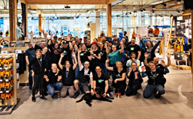
However, it was brought to my attention that there are some app issues including information being lost, and messages not being received. I have spoken to our Internal communications department and IT department to resolve the issues and will keep everyone updated as soon as we get it fixed.
I’d like to thank the entire team at the Ottawa location again for inviting me for a visit and I can’t wait to come back. I'll be more prepared for our next race @ChloeAlbertson, so watch out!
(The entire team ready for the day’s adventure)
Venture on,
Matts Andersen

Appendix R
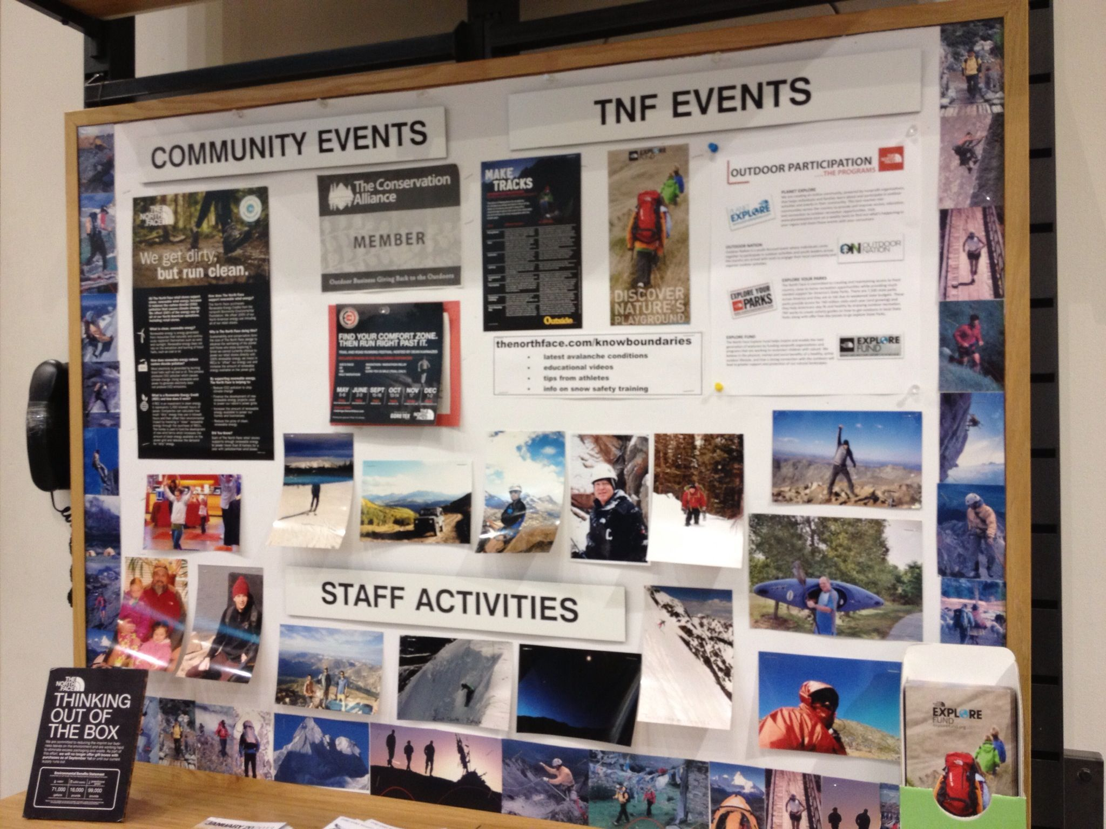
Above, a vision of what the Adventure Wall will look like.
Below, the kind of content to include.

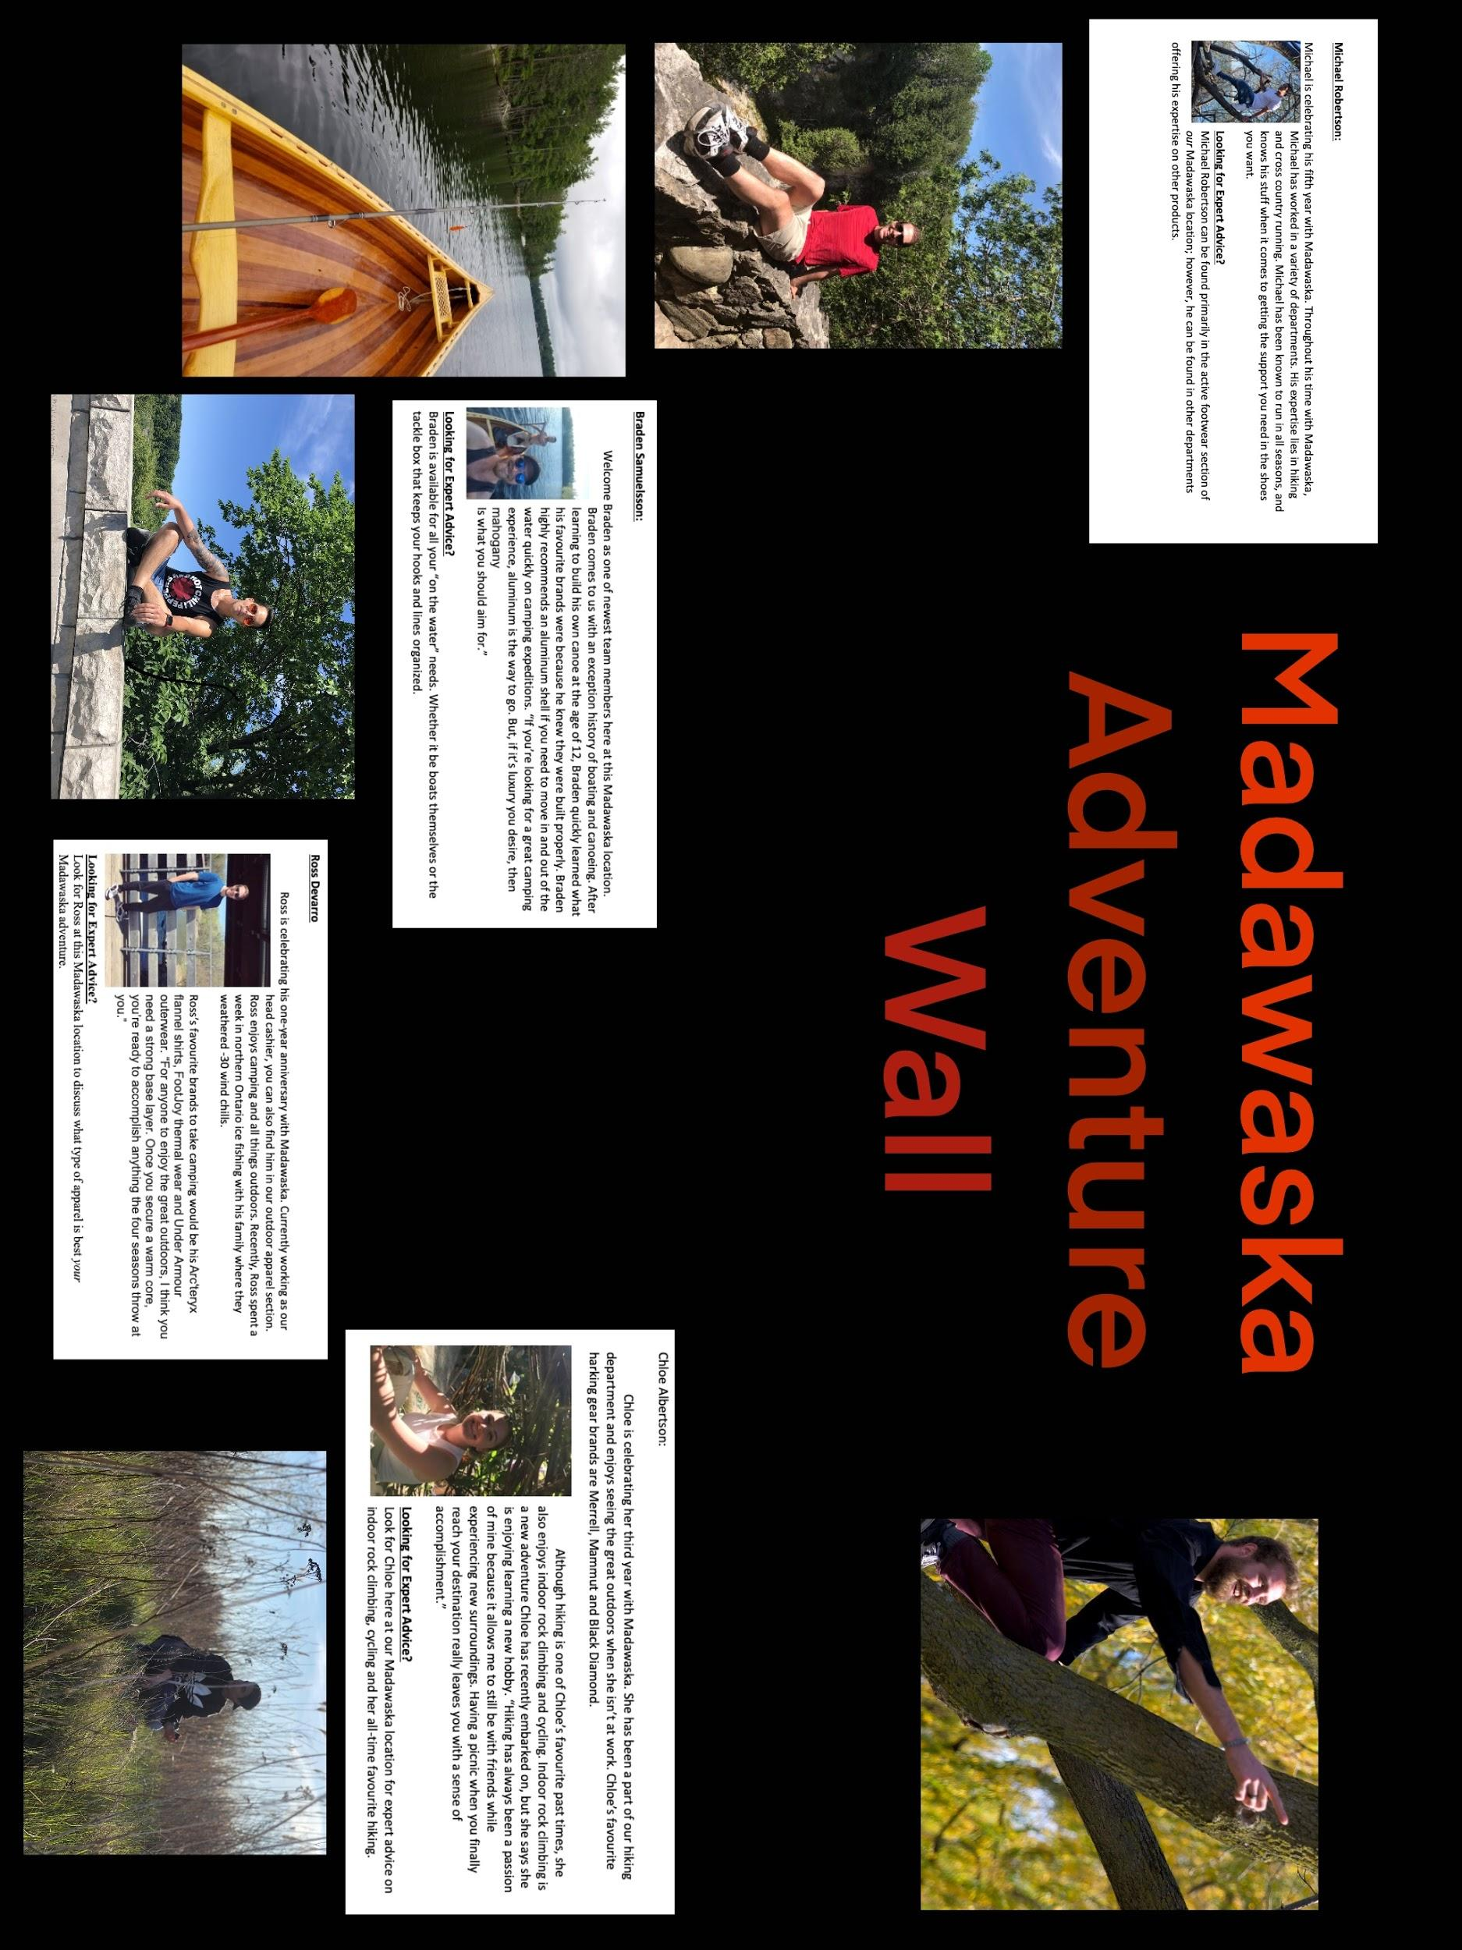

Appendix S
Chloe Albertson:
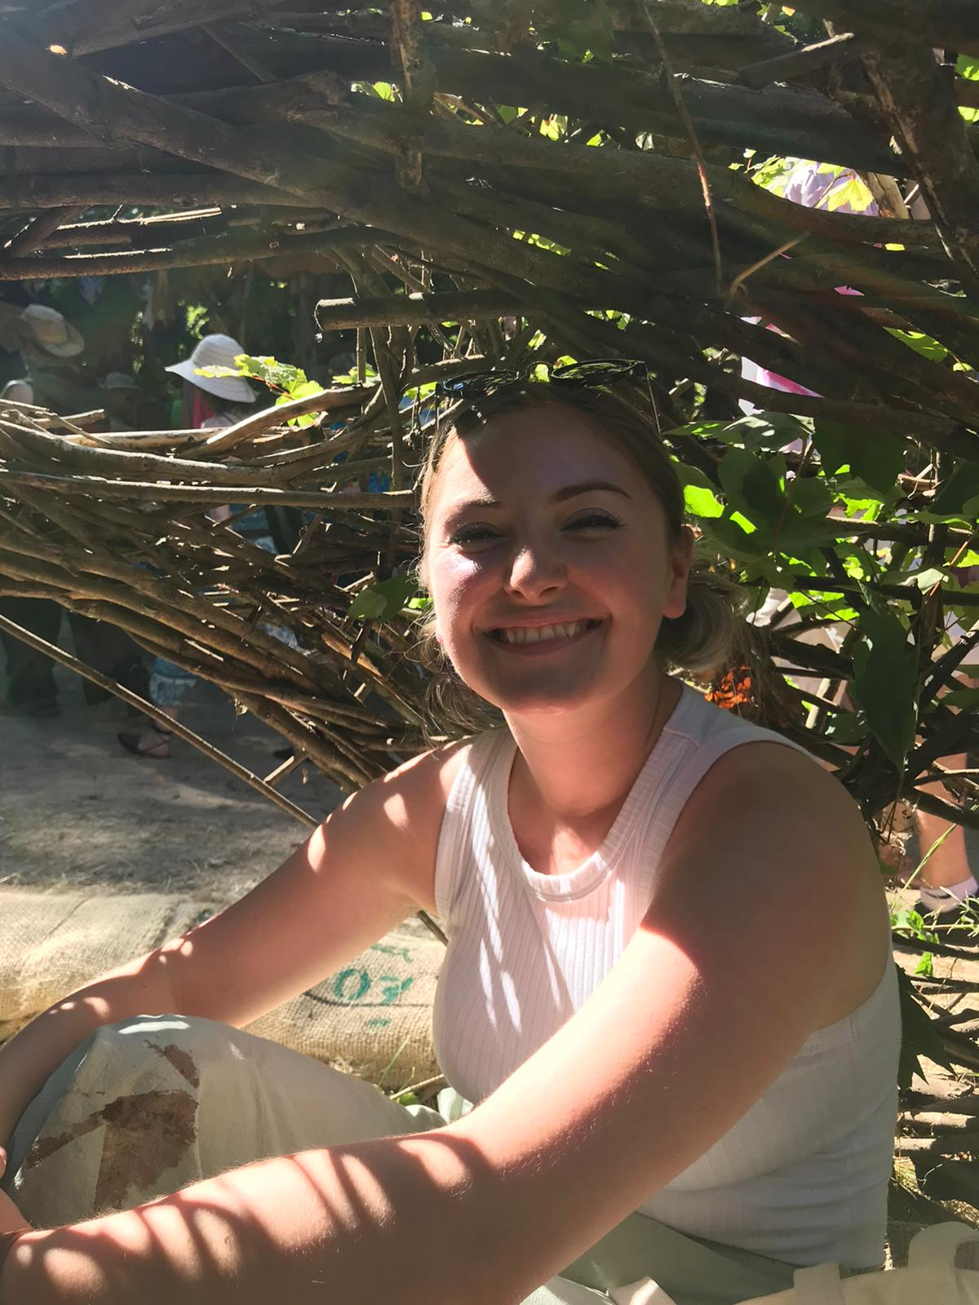
Chloe is celebrating her third year with Madawaska. She has been a part of our hiking department and enjoys seeing the great outdoors when she isn’t at work. Chloe’s favourite hiking gear brands are Merrell, Mammut and Black Diamond.
Although hiking is one of Chloe’s favourite past times, she also enjoys indoor rock climbing and cycling. Indoor rock climbing is a new adventure Chloe has recently embarked on, but says she enjoys learning a new hobby. “Hiking has always been a passion of mine because it allows me to still be with friends while experiencing new surroundings. Having a picnic when you finally reach your destination really leaves you with a sense of accomplishment.”

Looking For Expert Advice?
Look for Chloe here at our Madawaska location for expert advice on indoor rock climbing, cycling, and her all-time favourite hiking.

Ross Devarro
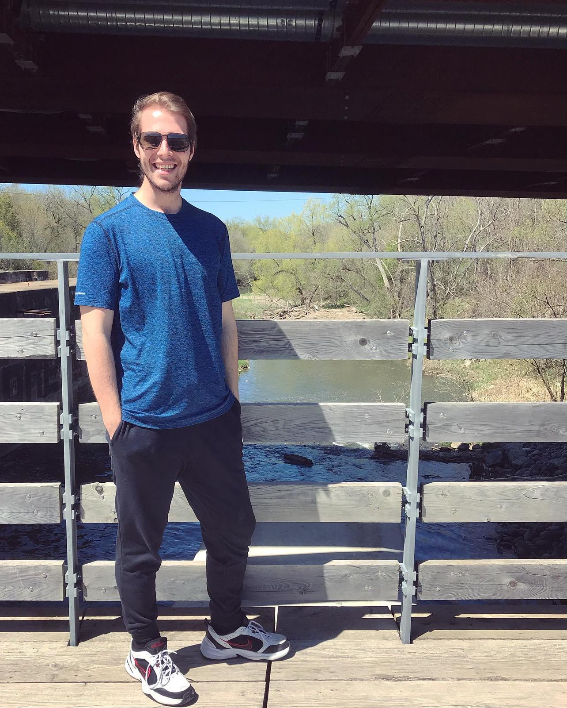
Ross is celebrating his one-year anniversary with Madawaska. Though he is currently working as our head cashier and is usually behind the register, you can also find him in our outdoor apparel section. Ross enjoys camping and all things outdoors. Recently, Ross spent a week in northern Ontario ice fishing with his family, where they weathered negative-30 wind chills.
Ross’s favourite brands to take camping would be his Arc'teryx flannel shirts, FootJoy thermal wear and Under Armour outerwear. “For anyone to enjoy the great outdoors, I think you need a strong base layer. Once you secure a warm core, you’re ready to accomplish anything the four seasons throw at you.”

Looking For Expert Advice?
Look for Ross at this Madawaska location to discuss what type of apparel is best for your Madawaska adventure.

Braden Samuelsson:

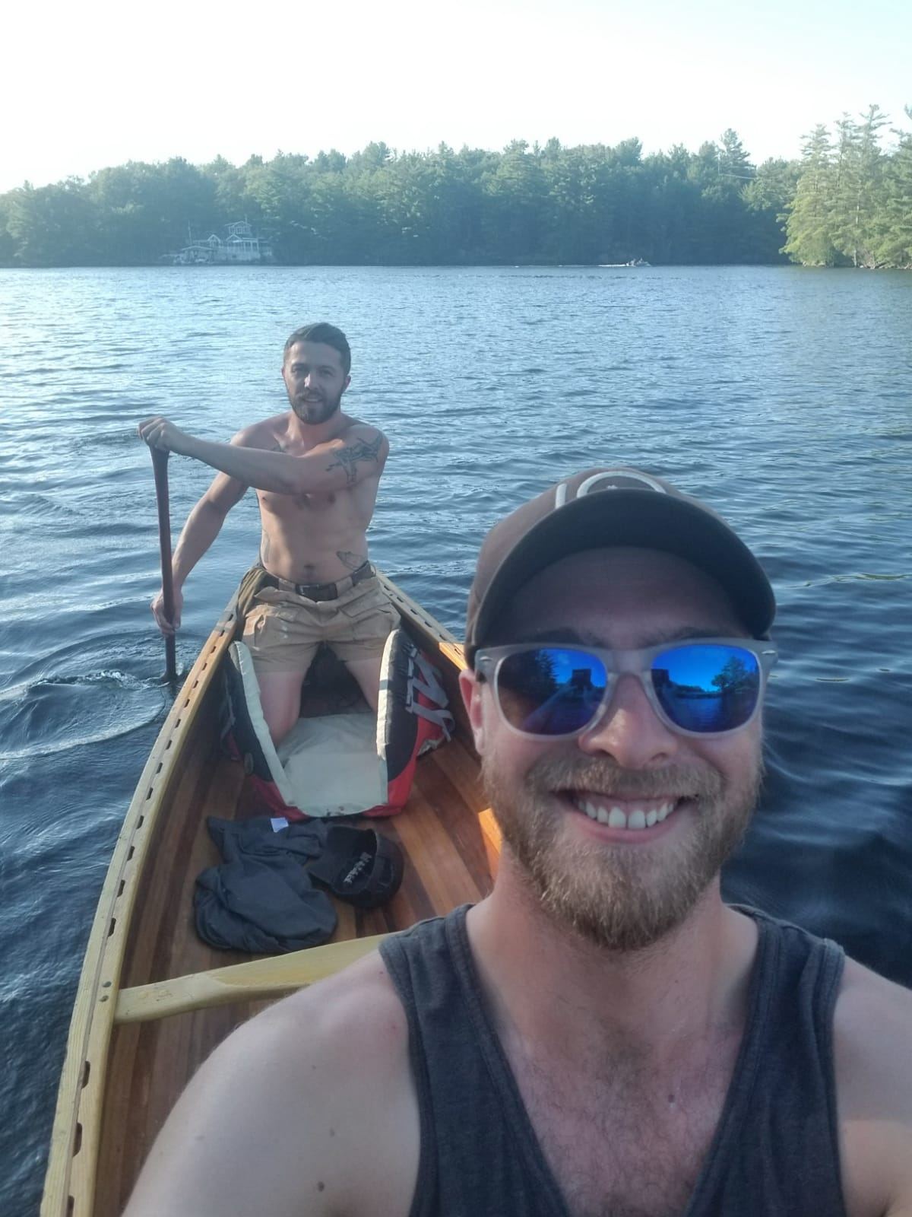
Welcome Braden, who is one of the newest team members here at this Madawaska location. Braden comes to us with an exceptional history of boating and canoeing. After learning to build his canoe at the age of 12, Braden quickly learned his favourite brands because he knew they were built properly. Braden highly recommends a cedar strip if you need to move in and out of the water quickly on camping expeditions. “If you’re looking for a great camping experience, a cedar strip is the way to go. But, if it’s luxury you desire, then mahogany is what you should aim for.”

Looking For Expert Advice?
Braden is available for all your “on the water” needs. Whether it’s boats or a tackle box to keep your hooks and lines organized.

Michael Robertson:

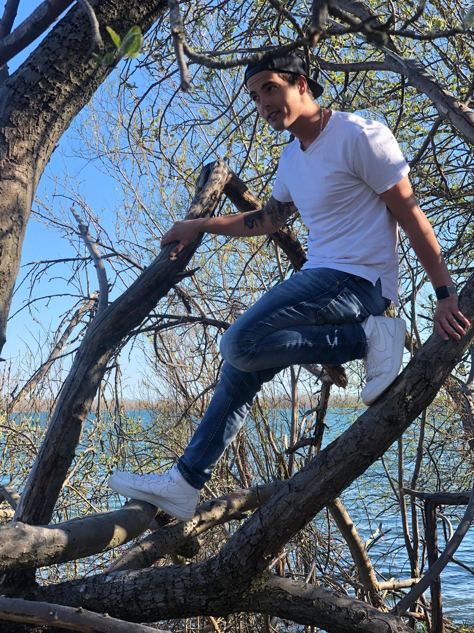
Michael is celebrating his fifth year with Madawaska. Throughout his time with Madawaska, Michael has worked in a variety of departments. His expertise lies in hiking and cross country running. Michael has been known to run in all seasons, and knows his stuff when it comes to getting the support you need in the shoes you want.
Looking for Expert Advice?
Michael can be found primarily in our Madawaska location’s active footwear section; however, he can be found in other departments offering his expertise on other products.

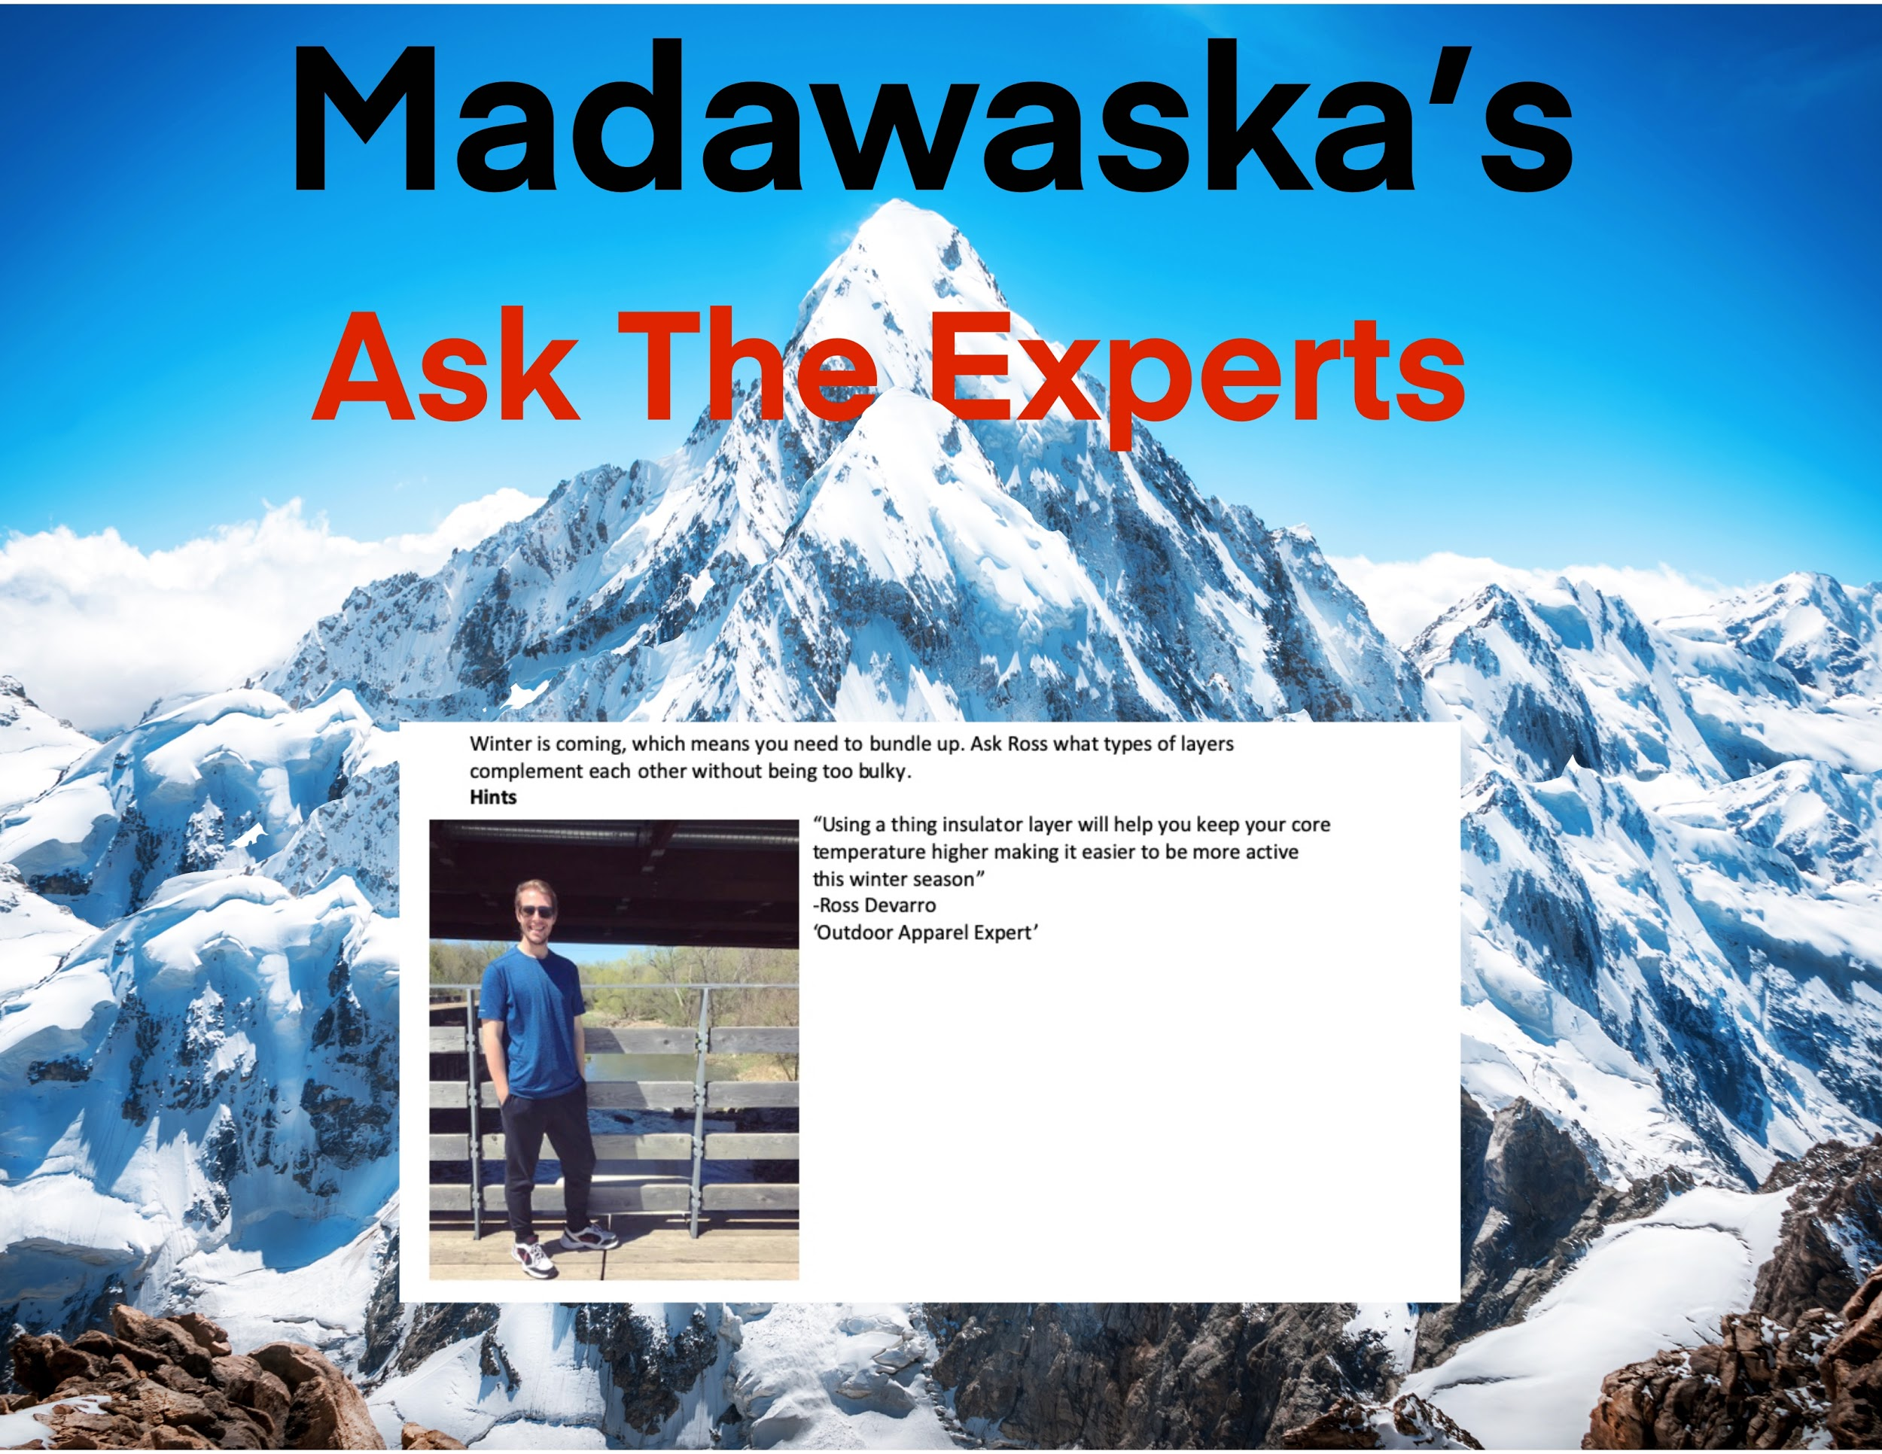Example of in-store recognition

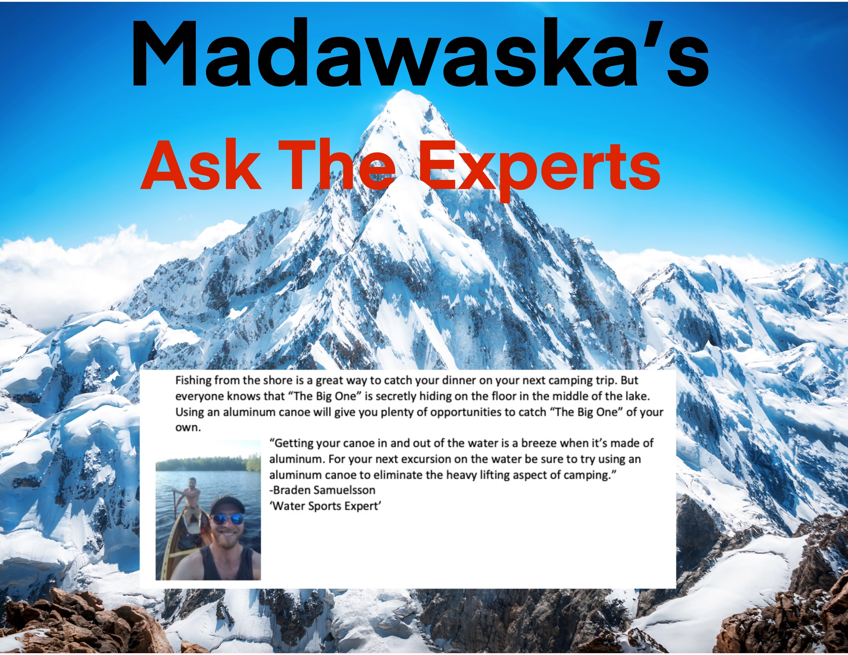Example of in-store recognition
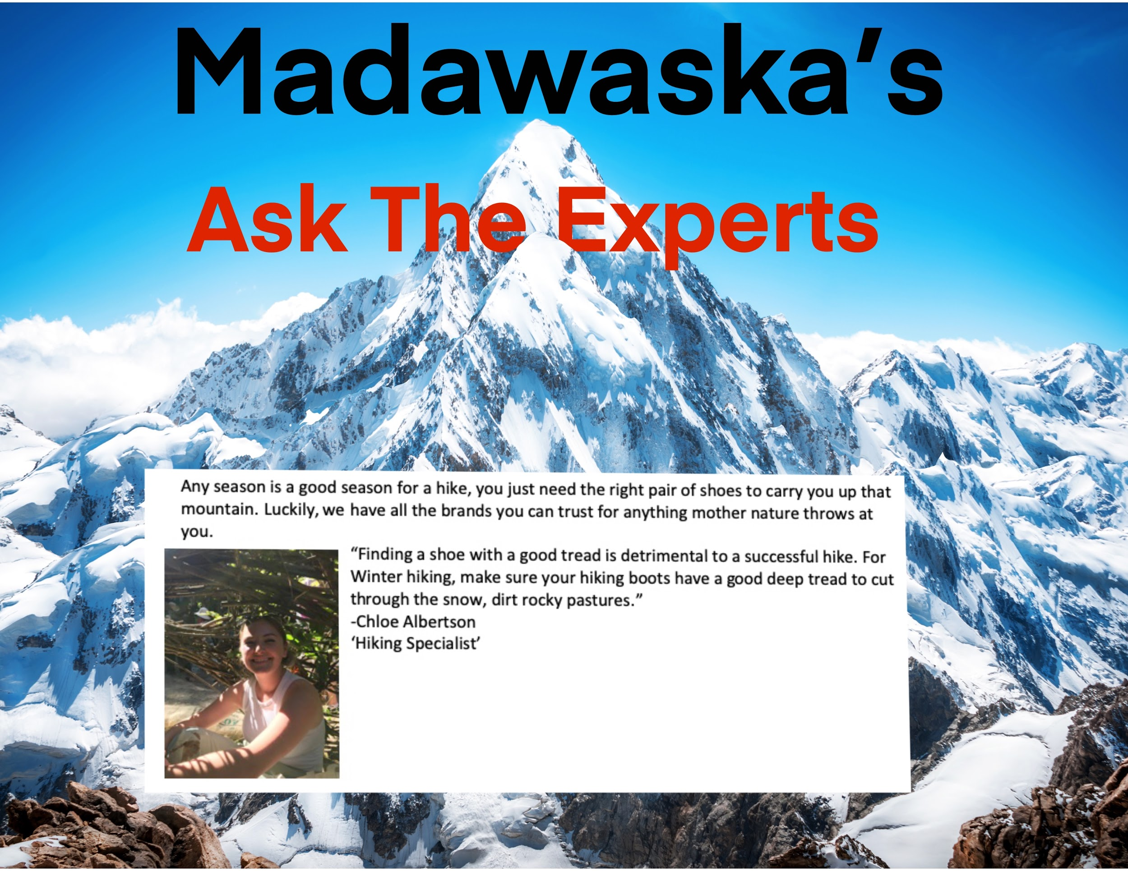Example of in-store recognition.
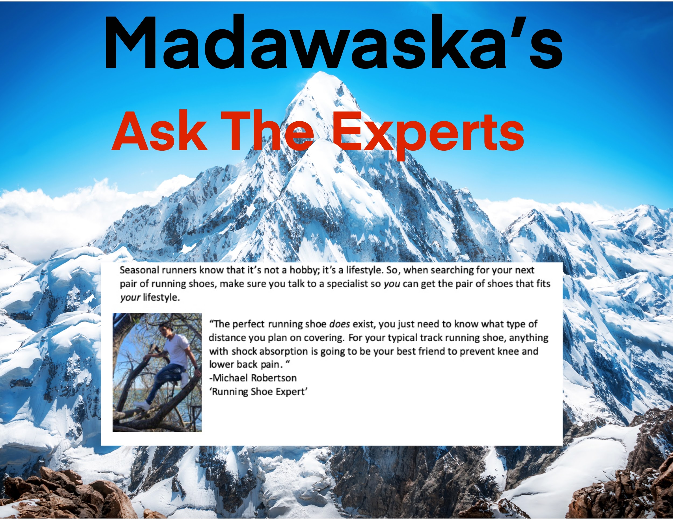Example of in-store recognition

Appendix T

Hello adventurers,
It looks like the new Adventure Wall forum has been getting lots of attention lately, and we are excited that employees want to share their stories.
This forum was created to give each one of you a voice and to be able to connect.
We encourage everyone to continue sharing their stories and writing about their outdoor experiences, and that includes the management team as well.
We have also received some feedback from our community and understand that some adventurers want to “see” more. Now under the Adventure Wall forum, a dedicated photo gallery will host all the photos and videos uploaded to the page.
We hope that this will make it simpler for everyone to share their digital memories with the rest of our community.
If you have any other suggestions that you feel may help or improve our communication platform, or if there is something you’d like to see in the future you can reach out to us at askmadawaska@outlook.com

Adventure is on the horizon,
Sofie Anderson, COO

Appendix U
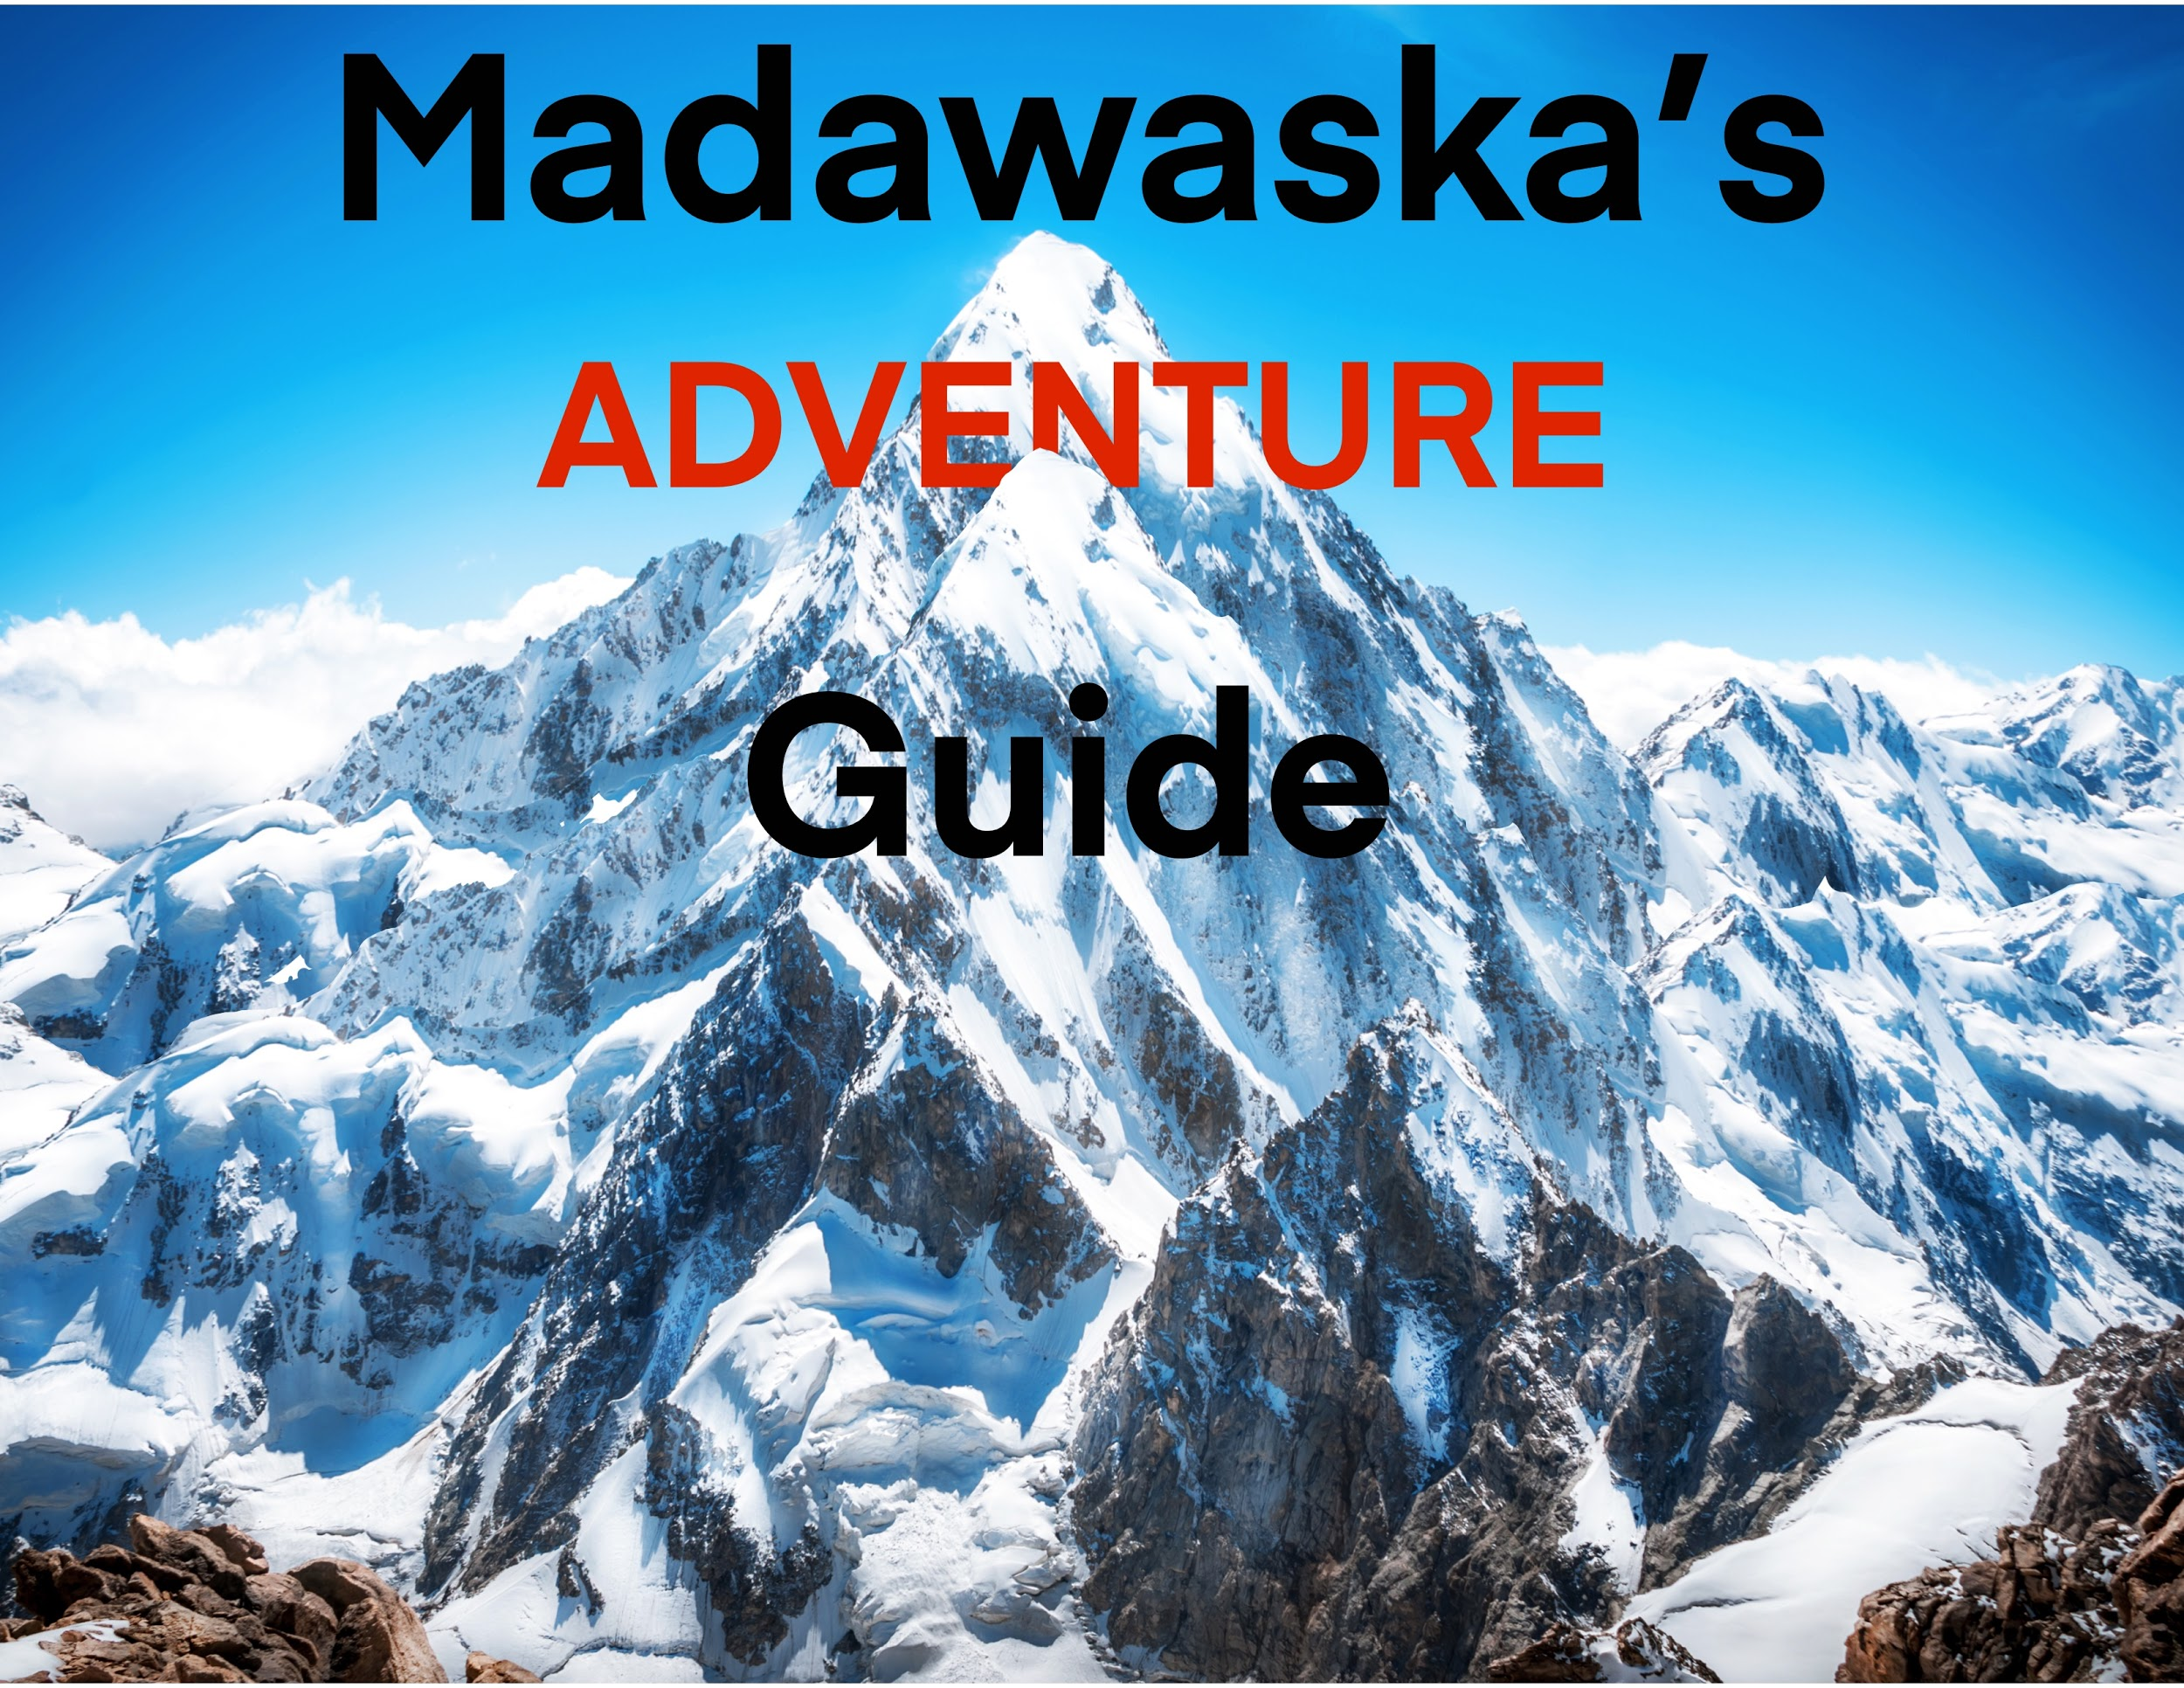

Madawaska Adventures: ADVENTURE GUIDE
WELCOME LETTER ii
- 1 Madawaska BACKGROUND INFORMATION 1
  - 1.1 A Brief History of xxx 1

- 2 INTRODUCTION TO THIS HANDBOOK 3
  - 2.1 Purpose of the Madawaska Adventure’s Handbook 3
  - 2.2 Human Resources Philosophy 3
  - 2.3 Definitions of Terms 3

- 3 HUMAN RESOURCE POLICIES 5
  - 3.1 Employment-At-Will 5
  - 3.2 Equal Employment Opportunity/Affirmative Action 5
  - 3.3 Employees with Disabilities Act 6
  - 3.4 Harassment-Free Workplace 7
  - 3.5 Drug-Free Workplace 9
  - 3.6 Personnel Records 9

- 4 CODE OF CONDUCT 11
  - 4.1 Business Ethics and Conduct 11
  - 4.2 Company Expectations of Employee Behavior 13

- 5 EMPLOYEE RELATIONS AND COMMUNICATIONS 15
  - 5.1 Employee Problem Solving Process 15
  - 5.2 Online Message Boards 16
  - 5.3 Guidelines for Intranet Communications/Workplace App

Madawaska Adventure Guide:

Welcome to the first stage of your new adventure here at Madawaska Adventures. In this adventure guide, you will find many things to help you succeed both inside and outside of Madawaska Adventure’s doors.

Here at Madawaska Adventures, we believe that a work hard, play hard culture is a must. So when you’re not in store, we strongly recommend going out and enjoying the great outdoors. In the back of this booklet you will find empty pages; this is where you can fill in some exciting adventures you have encountered. This is not just for outside of work either. Learn something new about a piece of equipment we carry? Write down all the ways you would like to enjoy using it! Work a crazy-busy holiday shift? Write down how it made you feel. Each year, Madawaska holds an award gala where you can submit some of your most exciting moments to your management team and get the chance to be nominated and win an award.

Madawaska Adventures knows that the great outdoors is calling your name, and we want you to answer that call as often as possible. This is why we have all our employees download the Workplace app, available in all app/google play stores.

This app will allow you to connect with coworkers to either pick up a shift or give a shift away. All shift swapping will need approval from management and usually takes 12-24 hours to filter.

Throughout this booklet, you’ll find helpful information to make your learning experience at Madawaska Adventures as easy as possible. If you are experiencing any issues, or just need basic information about how we do things around here, simply refer to this Adventure Guide for reference.

